Was the Boston Massacre really a massacre?

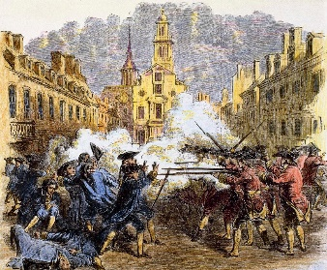

Massacre: *noun* the act or instance of killing a number of

usually helpless or unresisting human beings under

circumstances of atrocity or cruelty.

The **Boston Massacre** was the result of growing

tension in Boston in 1770. In October 1768, the **Commission of Customs** was created by the **Townshend Act** to collect taxes on goods and to prevent smuggling. The commission was not well received in Boston and called for a military guard to protect them. On October 1, 1768, a group of soldiers were sent to Boston with the job of protecting the commission. Almost immediately after the arrival of the soldiers, the people of Boston began taunting them by calling them names and spitting at them.

On March 5, 1770 the tension between the two sides ended with violence. A

small group was taunting the soldiers at the Customs House. One of the angered

soldiers hit a boy over the head with the butt of his musket then chased the small

group away. The group returned with more people who began to throw snowballs

and litter at the soldiers. The soldiers called for more help. A corporal and six

privates were dispatched. The group grew. They began throwing sticks, stones, and

chunks of ice. A group of sailors arrived with sticks and confronted the soldiers. A

wooden club was thrown and knocked down Private Hugh Montgomery. During

the commotion, someone yelled, “Fire!” All but one of the soldiers fired their

weapon. Three Americans died at the scene, a mulatto sailor Crispus Attucks,

ropemaker Samuel Grey, and mariner James Caldwell. Seventeen-year-old Samuel

Maverick, who was hit by a ricocheting bullet, died the next day, and Patrick Carr

died two weeks later. Six more were injured. A few days later, a public funeral was

held in which 10,000 people attended. This was the largest public gathering at that

time.

Some colonists who wanted radical change used the incident as an excuse to call for revolution (war for independence). They called the incident a massacre and claimed that the British government no longer cared about the colonists. The Sons of Liberty used the incident as an excuse to have large protests and cause more trouble for the British.

It was at this time that the educated men of the colonies began to establish themselves as symbols of American pride. George Washington, Thomas Jefferson, John Adams, and John Hancock all became leaders of a growing independence movement that would eventually ignite the Revolutionary War.

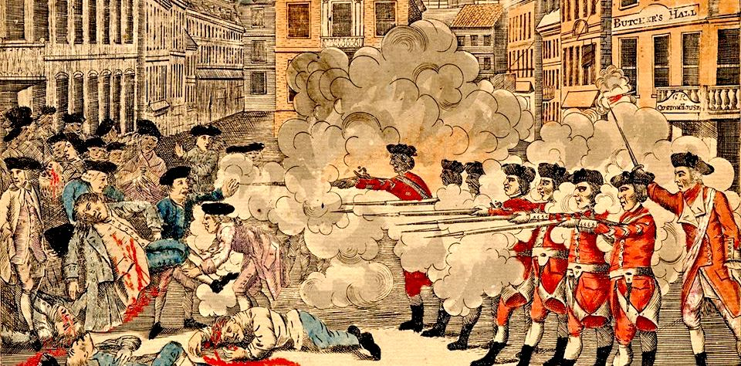Document 1: The Bloody Massacre in King-Street, March 5, 1770. Boston 1770. By Paul Rever

Respond to the following questions IN AT LEAST 3 SENTENCES EACH.

1. Describe the picture

The picture depicts two different groups of people. The one’s in red are attacking the people. The Boston people look at the soldiers who are shooting at them.

2. How are the British soldiers portrayed?

The British soldiers were portrayed as if they we’re murderers. The media and picture picturing them as if they started the attack. Though the colonists had started the attack with taunting them.

3. How are the colonists portrayed?

They’re portrayed as innocent because they are unarmed. People depicted them as brave and strong for surviving the “attack”.

4. If you were a colonist living during this time, how would you feel towards the British if you saw this image?

I would feel upset and afraid because I would think something like this will happen to me one day. I’d also be curious, wondering what started the attack and why it happened. I’d try to keep my distance and avoid the British as much as possible.

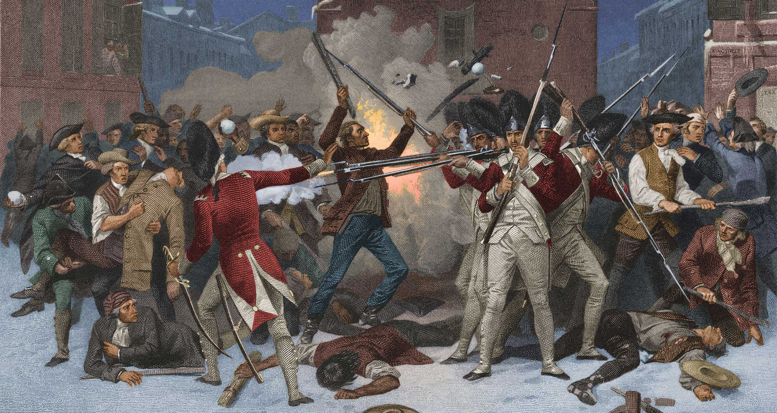Document 2

Respond to the following questions IN AT LEAST 3 SENTENCES EACH:

1. Describe the picture

Looking at the picture shown it looks as though the Boston people are attacking the Colonists. The soldiers are trying to defend themselves while also trying not to get stuck in the fire. It looks as if the Colonists started an argument that then turned violent.

2. How are the British soldiers portrayed?

The soldiers look like they are fending off the colonists. Defending themselves against the things being thrown at them.

3. How are the colonists portrayed?

Colonists are portrayed as they’re the ones being attacked at and then gaining the advantage in a altercation that happened because of how many there were of them. The colonists we’re seen as innocents and as if they we’re just protesting.

4. If you were a British Loyalist living during this time, how would you feel towards the colonists if you saw this image?

I would feel upset because they made it look as if we we’re the ones hurting the colonists without our side being shown. I would have tried my best to make sure my side of the story got out.

**Comparison to Today**

After the Boston Massacre, the media (newspapers / prints) spread the news of the massacre. The media displayed it in a way to support the colonists. How does media do that today with current protests and events going on? In other words, how does today’s media display only one side of the story? **Explain in at least 5 complete sentences.**

With how the Media does today with current protests and events, they exaggerate things more than needed. Along with only sharing one side of the story instead of both. Each side doesn’t get seen because it’s show from an assumption and one mere photo. With display, they show a video or a picture, etc. [Sometimes they aren’t clear] of what’s happening in the video but it’s only from one angle, POV, etc.

Firm British control and the colonists’ reaction to it, ultimately lead to the American Revolution and beginning of a new nation. What do you think might be the long-term effects of protests going on today? **Explain in at least 5 complete sentences.**

The effects of protesting in modern day [Not as in a generalization] have been confused with rioting and destruction. Sure, they mean it all in good meanings, but they go about it wrong. Ex. BLM, Israel, Guatemala Those protests we’re supposed/meant to be peaceful, but they quickly turned violent and destructive. I feel as if the long term effects of protesting can cause depression because you feel asif you and others that are protesting are being show as if they don’t matter. If physical violence is included in some of these protests, some people might have PTSD or might be a victim to these.